|  |  |
| --- | --- |
|  |  |
| **PROJECT 2 ETL** |  |
|  |  |
|  |  |
|  | *Meme – Lili - Emily*  *Technical Report* |

Description

We are in a new era of travel. - Before the COVID-19 pandemic, travel and tourism represented more than 10% of the global economy, powered by 56x growth in international travel from 1950 to 2019. But as travel boomed, so much of it became the same—all the same places at all the same times. Then in 2020, it came to a halt. International arrivals sank to their lowest level in more than 30 years; as pandemic restrictions gradually lift and travel restarts. We are shifting from travelling at all the same times to all the same old places to many of us living anywhere, at any time, for however long. This is not a temporary reaction to these many months of restrictions and isolation, it’s a step toward a world in which living and travelling are one and the same and is the top activity people say they will do first once they feel safe. But, where do people want to travel again?

In the following analysis, we explore Amsterdam’s Airbnb Market in 2018 – 2019 to give resources at the time of decision making as Amsterdam is the capital and most popular city of the Netherlands.

The Amsterdam Airbnb Dataset contains data about Airbnb listings in Amsterdam, calendar availability for each of these listings as well as user reviews on the listings. Using this dataset, In the following analysis, we explore Amsterdam’s Airbnb Market in 2018 – 2019 to give resources to tourist at the time of decision making. We are going to attempt to answer the following business questions:

1. How does pricing increase or decrease by neighborhood and which ones are the priciest neighborhoods in Amsterdam?
2. How does property types & Room types within neighborhoods impact price for the most expensive neighborhoods and most common property types?
3. Is there a Trend in Location?
4. What are the average reviews scores?

The answer of those question can be useful for people from Amsterdam who wants to start renting their properties on Airbnb, or tourists who are going to visit Amsterdam and want to estimate the cost of accommodation.

Analysis

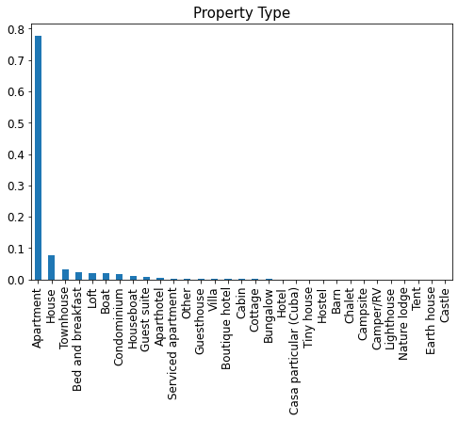

The graph represents on a descending scale the type of most rented property according to the listings being apartment in the first place.

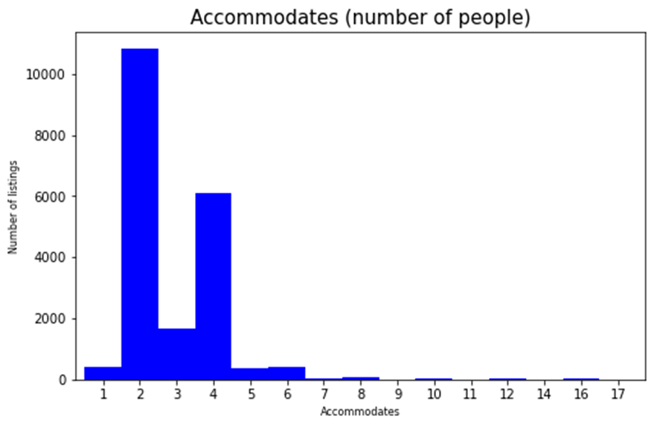

According to the number of listings the most preferred accommodation is for 2 and 4 people.

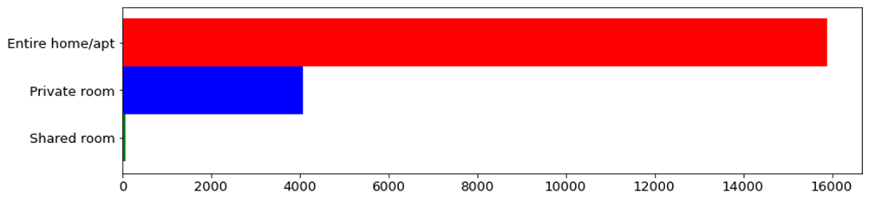

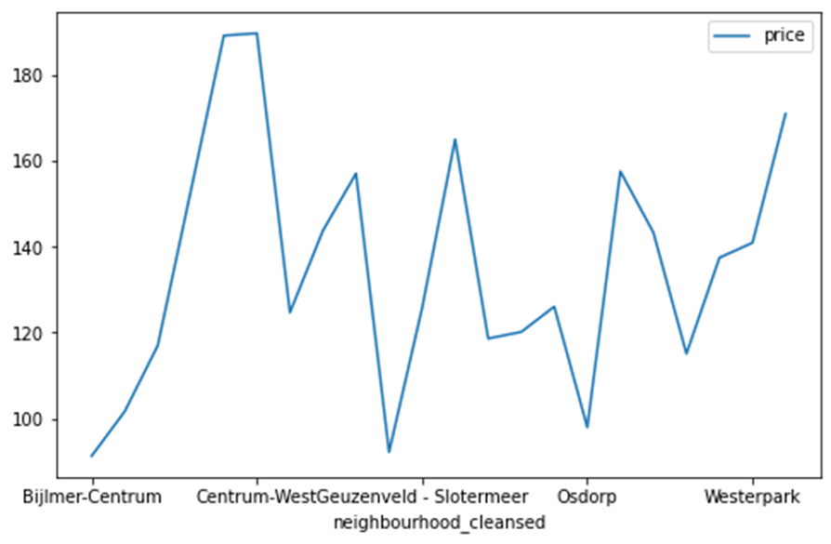

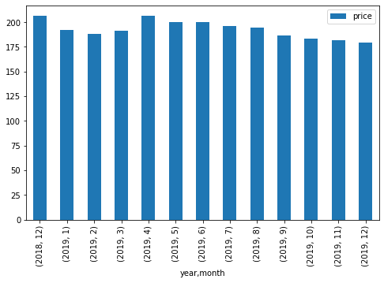

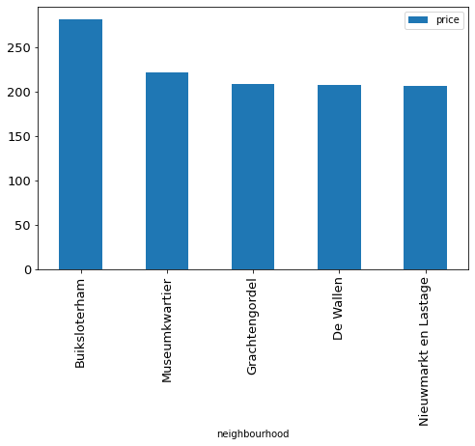



Based on the above analysis, there is definitely price fluctuations based on neighborhoods. The Centrum-West seems like the priciest of all, averaging at $280. Followed by Museumkwartier at $222. Osdorp seems like the cheapest at $111 average price.

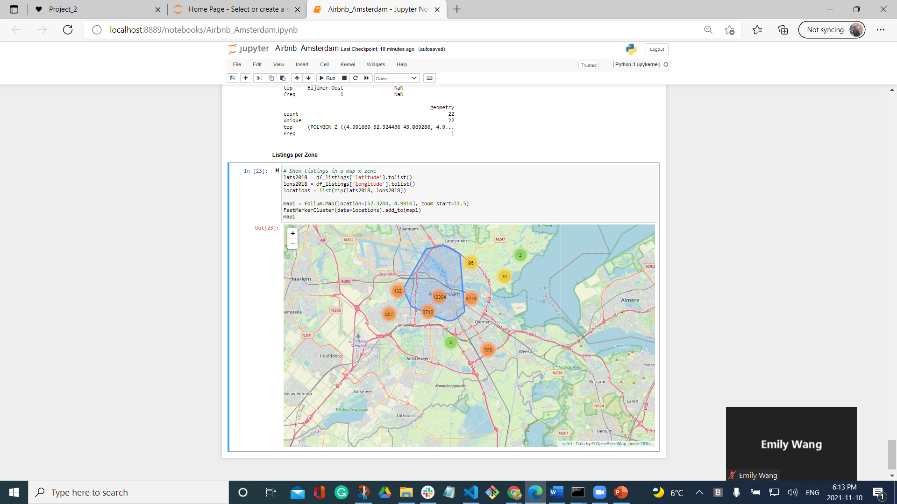

1. The previous map shows us the listings distributed by zones, with which we can determine that the center of the city is where the highest concentration of available properties is located.

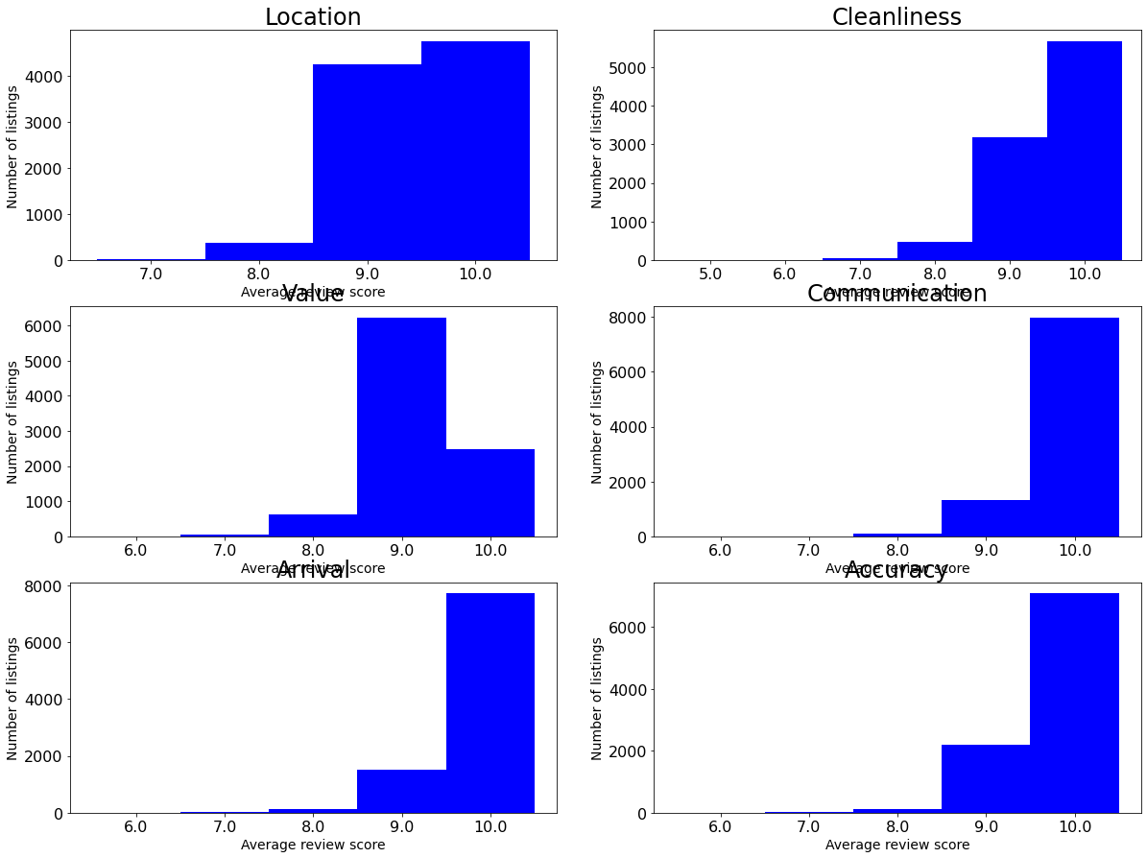

This graph corresponds to the averages of reviews for listings, distributed by location, Cleanliness, values, communication, arrival and accuracy. Which allows us to analyze some preferences.

# Conclusions

Reviews number vs. reviews score analysis correlation analysis: When we try to search for the choices of Airbnb, review score would be one of the considerations. We are thinking does the listing that has high review score means they are more popular in the market(which means a greater number of reviews)? A scatter plot was created between the review numbers and the review scores for each listing. In the Amsterdam Airbnb market, there was no strong correlation between the high scores and popularity. Some listings have high scores while their number of reviews are low. But the listing has low scores normally has fewer number of reviews. That is to say for the popular listings, the scores are normally exceed 80. So these two criteria combined can help people to search for the satisfied listing on the market.

Price changes between seasons: We all know the prices are vary between seasons, and we always want to choose the best price. So we take a look and analyze the price change between the seasons. To our surprise, the Christmas season ( December to January) was not a price peak from the analysis. Fall season, October has the highest average price with 165 and followed by August at 157. February has the lowest price at 119 $. Prices range for the year is around 50 dollars per night. So that we can know Amsterdam probably has more travellers during the summer and autumn seasons.